

VALENCIA COUNTY

BOARD OF COMMISSIONERS

ORDINANCE NO. 2025-

AN ORDINANCE AMENDING ORDINANCE # 2013-01, WHICH ADOPTED THE 2006 EDITION OF THE INTERNATIONAL FIRE CODE, IN ORDER TO ADOPT THE 2021 EDITION OF THE INTERNATIONAL FIRE CODE AND CURRENT (NFPA) NATIONAL FIRE PROTECTION ASSOCIATION, REGULATING AND GOVERNING THE SAFEGUARDING OF LIFE AND PROPERTY FROM FIRE AND EXPLOSION HAZARDS ARISING FROM THE STORAGE, HANDLING AND USE OF HAZARDOUS SUBSTANCES, MATERIALS AND DEVICES, AND FROM CONDITIONS HAZARDOUS TO LIFE OR PROPERTY IN THE OCCUPANCY OF BUILDINGS AND PREMISES IN THE UNINCORPORATED AREA OF VALENCIA COUNTY; PROVIDING FOR THE ISSUANCE OF PERMITS AND COLLECTION OF FEES THEREFORE,

2.14.040 – Adoption of Fire Code
For the purpose of prescribing minimum standards regulating conditions hazardous to life and property from fire and explosion within the boundaries of the Unincorporated area of Valencia County, New Mexico the following code is adopted.
A. A certain document, one (1) copy of which is on file in the office of the Valencia County Fire Department, being marked and designated as the International Fire Code, 2021 edition, including Appendix Chapters D, I , (see International Fire Code Section 101.2.1, 2021 edition), as published by the International Code Council, and the National Fire Protection Association (NFPA) current codes as needed, be and is hereby adopted as the Fire Code of the Valencia County Fire Department, in the State of New Mexico regulating and governing the safeguarding of life and property from fire and explosion hazards arising from the storage, handling and use of hazardous substances, materials and devices, and from conditions hazardous to life or property in the occupancy of buildings and premises as herein provided; providing for the issuance of permits and collection of fees therefor; and each and all of the regulations, provisions, penalties, conditions and terms of said Fire Code on file in the office of the Valencia County Fire Department are hereby referred to, adopted, and made a part hereof, as if fully set out in this ordinance, with the additions, insertions, deletions and changes, if any, prescribed in this ordinance.
B. The following sections are hereby revised:
- Section 101.1 Insert: Valencia County Fire Department
- Section 104 Duties and Powers of the Fire Code Official. If Section 104.6 (official records) or any other provision of the Fire Code conflicts with the Inspection of Public Records Act, Sections 14-2-1 through 14-2-12 NMSA 1978, the provisions of the Inspection of Public Records Act shall control.
- Section 106.1 Construction documents: submittals. This section is deleted in its entirety and replaced with the following language:
      - One set of construction documents shall be submitted to the Fire Code Official, who is the AHJ for the construction project.
      - All construction documents that are submitted to the Fire Code Official shall comply with the plans submittal information provided by the Fire Code Official on their respective website (fire_command_staff@co.valencia.nm.us) and shall be submitted with the applicant's certificate of fitness number, permit application and permit number or building official unique identifier and shall comply with the approval process provided in 10.25.5.16 NMAC and with the CID regulation on permits, CID rule 14.5.2 NMAC.
- Section 112.4 Insert: misdemeanor, $500.00, 90 days
- Section 111.4 Insert: A person shall be liable to a fine of not less than $500.00 dollars and not more than $1500.00 dollars.
- Section 405.3 Frequency. This section of the IFC shall not apply. PED rule 6.29.1.8 NMAC emergency drills and practiced evacuations shall apply
- Section 503.6.1. Insert [Minimum gate width] Approved gates will have a minimum opening of 12 feet.
- Section 504.4 Insert [Marking of egress doors. In order to establish consistent means of identifying access doors in large occupancies for the purpose of assisting responding emergency personnel during firefighting operations where required by the fire code official.
- Section 504.4.1 Insert [ Required access doors (including exit doors) that serve areas of large commercial/industrial buildings shall be marked in accordance with this section, when required by the fire code official, to allow for quick identification by firefighters both inside and outside of the building.
- Section 504.4.2 Insert [Identification method (see attached example):
a. A sequential system shall be utilized.
b. Each door will be identified by the letter representing the direction of orientation (S-south, W-west, N-north, E-east), followed by the appropriate number as described and illustrated below.
(1) Marking on the north side of the building shall start at the northwest corner beginning with the designation N1 and proceeding east.
(2) Marking on the east side of the building shall start at the northeast corner beginning with the designation E1 and proceeding south.
(3) Marking on the south side of the building shall start at the southwest corner beginning with the designation S1 and proceeding east.
(4) Marking on the west side of the building shall start at the northwest corner beginning with the designation W1 and proceeding south
c. Identification material shall be four-inch reflective adhesive letters/numbers of a color that contrasts with the color of the door.
d. Identification marking shall be located on both the inside and the outside of the door. The interior side of the doors shall be marked two inches above the bottom of the door in the center and the outside shall be marked on the top left corner 2 inches from the top of the door.
e. When a new tenant improvement is proposed in an existing building where the doors are not already identified in accordance with this section, the new door identification shall take into consideration all of the doors serving the entire building to ensure that the number designation is consistent with a presumed numbering system that meets the requirements of this section.
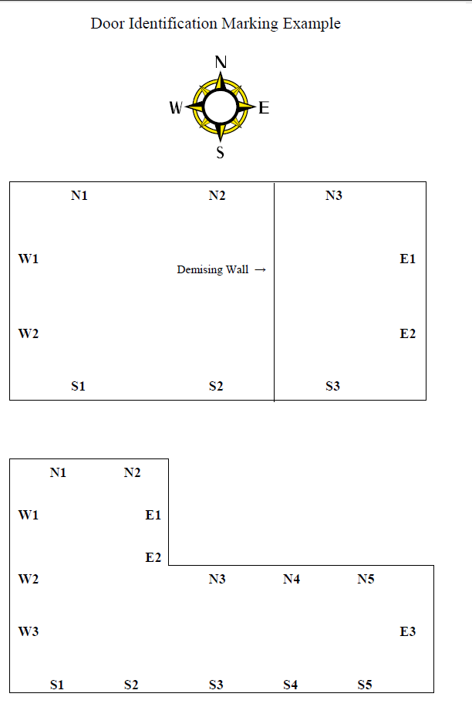
- Section 506.1.1 Insert [Knox-Box®. The Valencia County Fire Department utilizes the Knox-Box® rapid entry system and requires all new buildings and vehicle charging stations to be equipped with at least one box placed in an approved location.]
- CHAPTER 9 FIRE PROTECTION SYSTEMS: Throughout chapter 9, the following shall apply:
      - Delete the term "International Mechanical Code" where used in this chapter and replace with the term "New Mexico Mechanical Code".
      - Delete the term "International Plumbing Code" where used in this chapter and replace with the term "New Mexico Plumbing Code".
- Section 903.3.8.5 Calculations. Add “A 10 psi safety factor shall be added to all hydraulic calculations as mandated by the AHJ”.
- Section 904.13 Commercial cooking systems. The replacement of commercial cooking equipment, including but not limited to a stove, hood, deep fryer, grill, griddle, or any other device used in the cooking process, shall comply with this Section and with the Uniform Mechanical Code as adopted by reference in CID rule 14.9.2.13 NMAC.
- Section 905.3.4.1 Hose and Cabinet. Insert the following sentence at the end of this section, "Unless required by a fire code official, one and one-half inch hoses and hose cabinets are not required for class II and class III standpipe systems.
- CHAPTER 56 EXPLOSIVES AND FIREWORKS: This chapter of the IFC and 10.25.6 NMAC apply to fireworks. If there is any conflict between this chapter of the IFC and the Fireworks Licensing and Safety Act, Sections 60-2C-1 through 60-2C-11 NMSA 1978, the Fireworks Licensing and Safety Act shall control.

ORDAINED, APPROVED, AND ADOPTED THIS 2ND DAY OF APRIL 2025 BY THE BOARD OF COUNTY COMMISSIONERS OF VALENCIA COUNTY, NEW MEXICO.

.

_____________________________ _______________________________
Gerard Saiz Troy Richardson
Chairman, District I Vice-Chairman, District II

_____________________________ _______________________________
Morris Sparkman Joseph Bizzell
Commissioner, District III Commissioner, District IV

_____________________________
Dante Berry
Commissioner, District V

Attest:

_____________________________
Mike Milam, County Clerk

